Introduction

I hope most of you are aware of the process of performing a assignment change action on a employee record from an HR Administrator login but many a times there may be a requirement where-n we may have to perform a Mass Assignment Change. Say for example the requirement is to move all employees who are based out of Dallas location and having Job as ‘Project Specialist’ should be moved to Redwood City as a Human Resources Generalist. This can be accomplished in two ways:

1. Bulk Update using HDL / HSDL / Rest API services
2. From UI using Mass Assignment Change

A HR administrator might get such requests quite frequently and he / she may not be very well verse with HDL / HSDL / Rest API Services which require some level of technical expertise and competency and so performing this action using UI is the best approach.

So without further ado let’s get started on the UI approach.

Worked Example

We would need to login to application with HR Admin login (individual who has all the right roles and privileges) and then navigate to ***My Client Groups -> Mass Updates -> Create Mass Assignment Change***

and we can populate the following details:

|  |  |
| --- | --- |
| Attribute Name | Attribute Value |
| *Name | Dallas (Project Specialist) -> Redwood City (Human Resource Generalist) |
| Description | Move All Employees from Dallas who are working as Project Specialist to Redwood City as Human Resource Generalist |
| *Effective Date | 4/30/2020 |
| *Action | Assignment Change |
| Action Reasons | Career Progression |
| Assignments with Future Changes | Show Errors and Exclude Assignments |

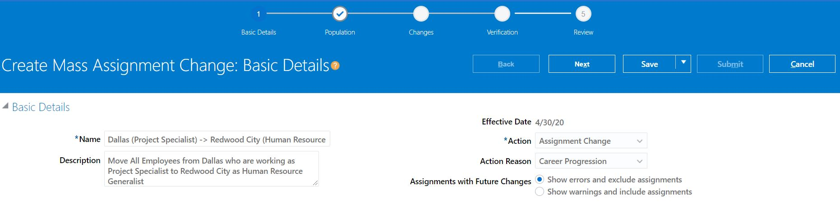

We can click on Next and choose the population as per our requirement

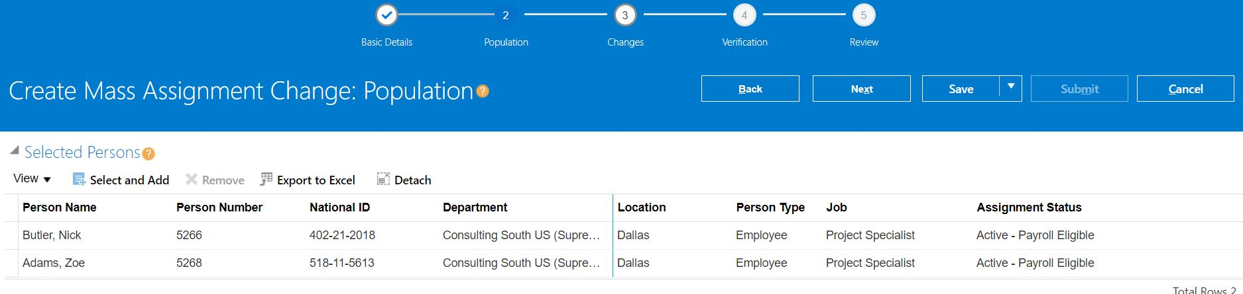

Now we can click on Next and make changes to these employee records

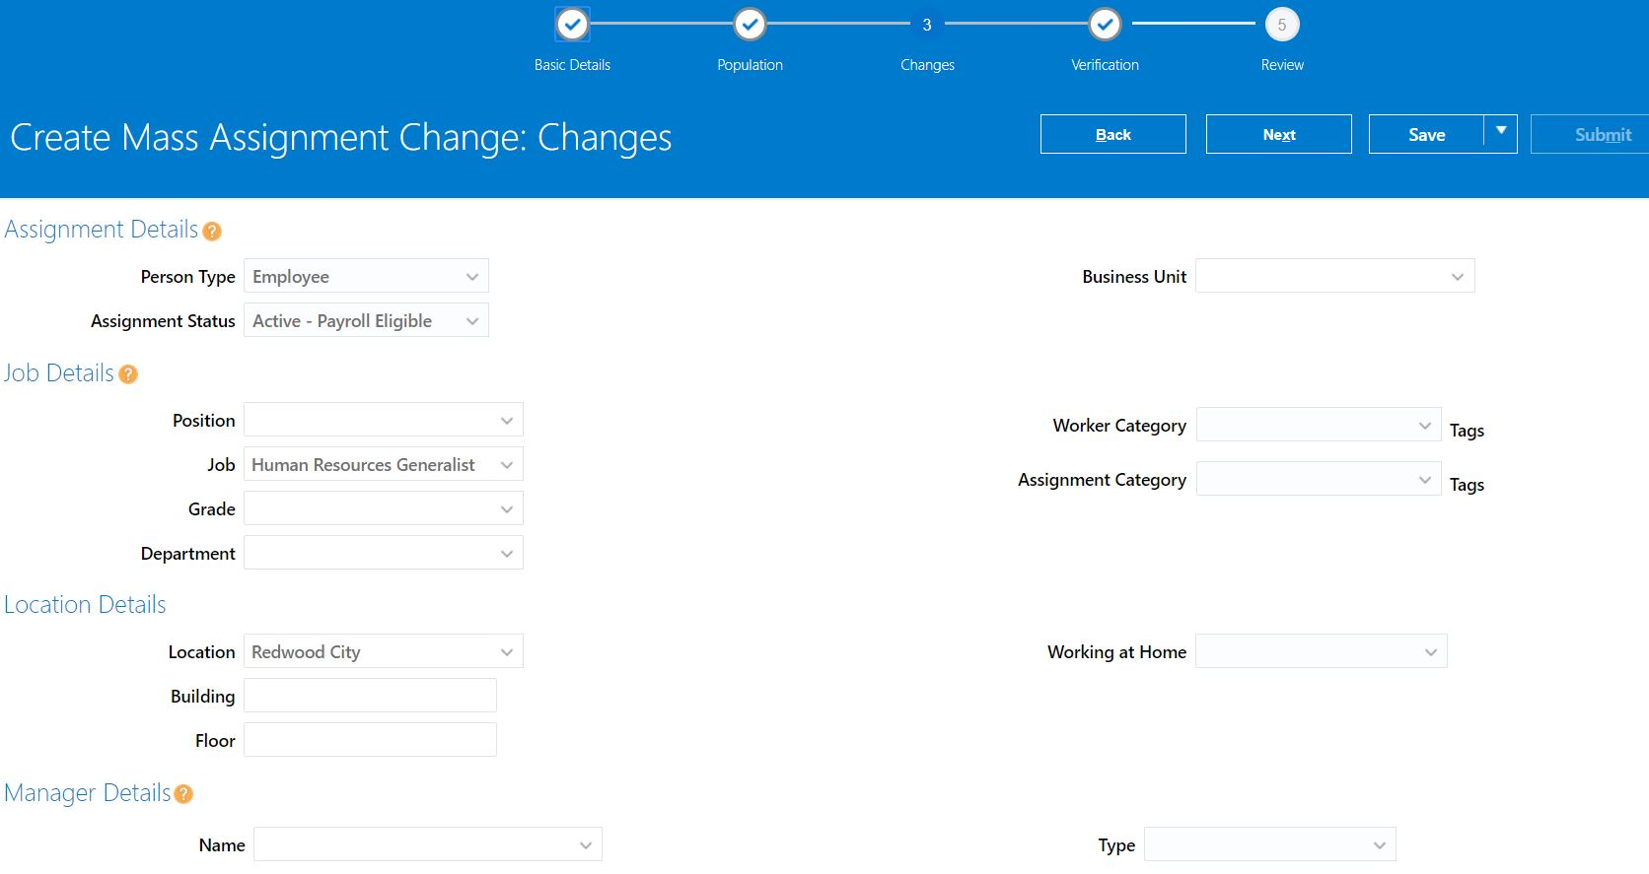

We would now click on next and move to ‘Verification’ tab . If there are no issues with the changes proposed then the status field will show a tick-mark (as shown below)

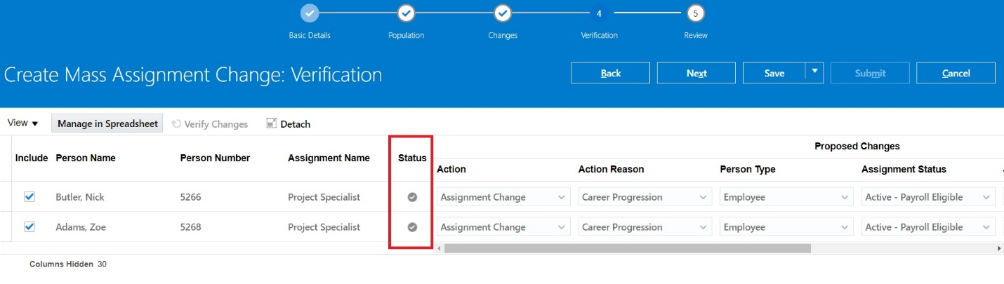

Now we can click on Next button and we will be on “Review” page

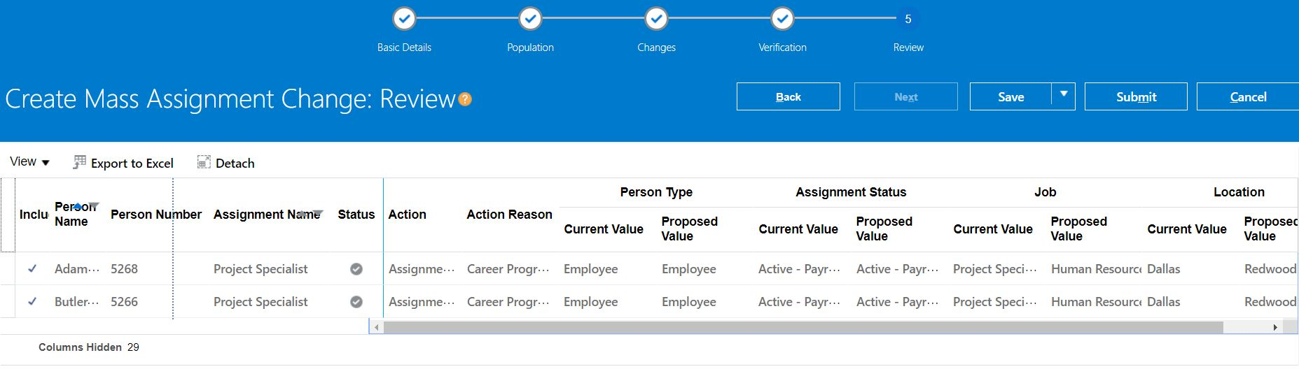

We should now click on ‘Submit’ button.

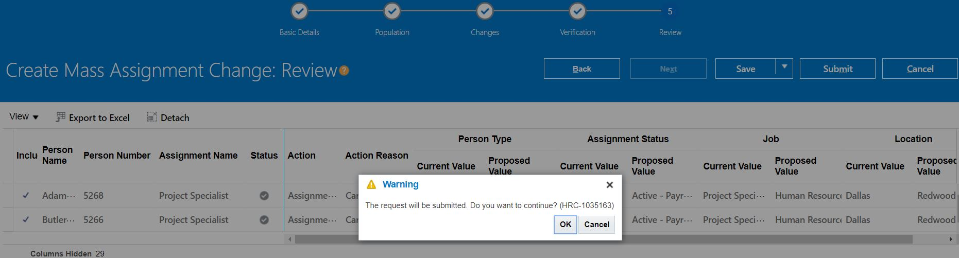

Once we click on OK the transaction is complete.

In the next step we will perform a quick verification

Verification

We would now navigate to Person Management and check employment record details for Employee# 5268

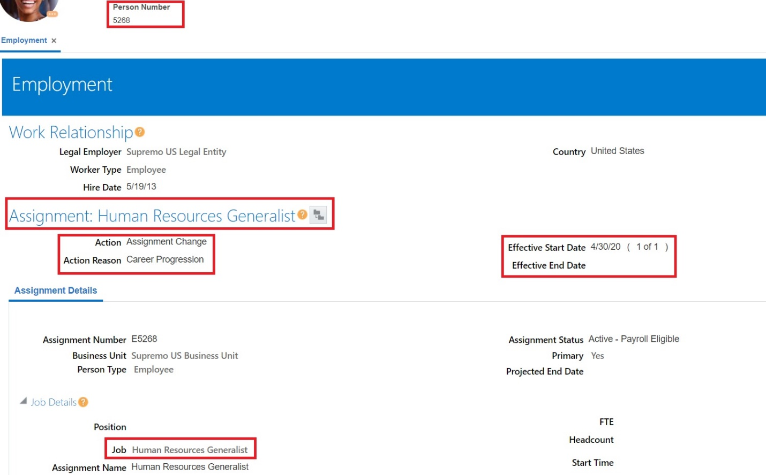

From the above screenshot we can clearly see that the assignment change s successful.